Task 1: Separating Odd and Even Elements in an Array
Objective: Create two arrays of 10 random elements each. Loop through the arrays and separate the odd and even numbers.
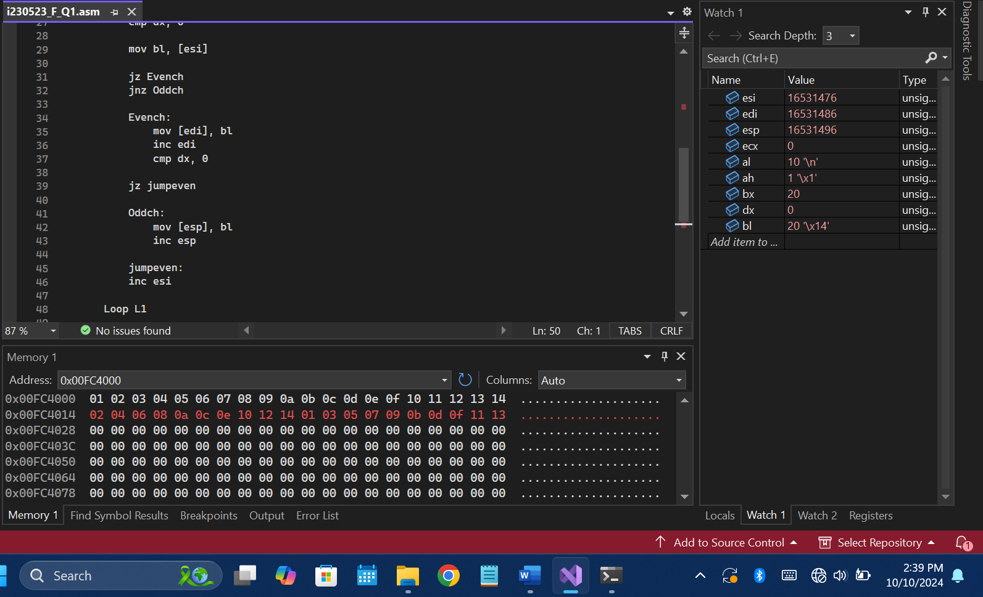
Task 2: Separating Negative Elements in an Array
Objective: Create an array of 10 elements, each ranging from -128 to 127. Loop through the array and isolate the negative elements.
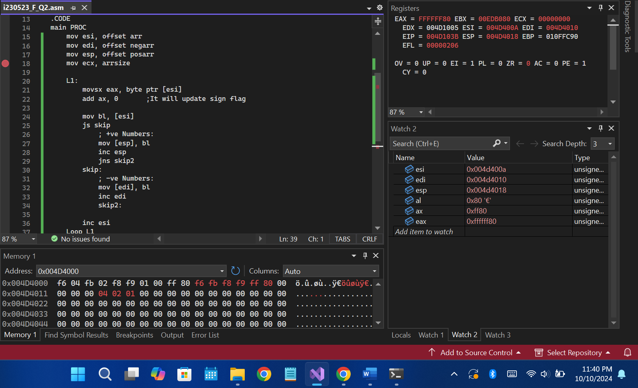
Task 3: Bitwise Masking to Extract Values
Objective: Given the hexadecimal word 8575h, extract specific values using bitwise masking:
5 in AL, 75 in AH, 0575 in BX, and 8505 in CX.
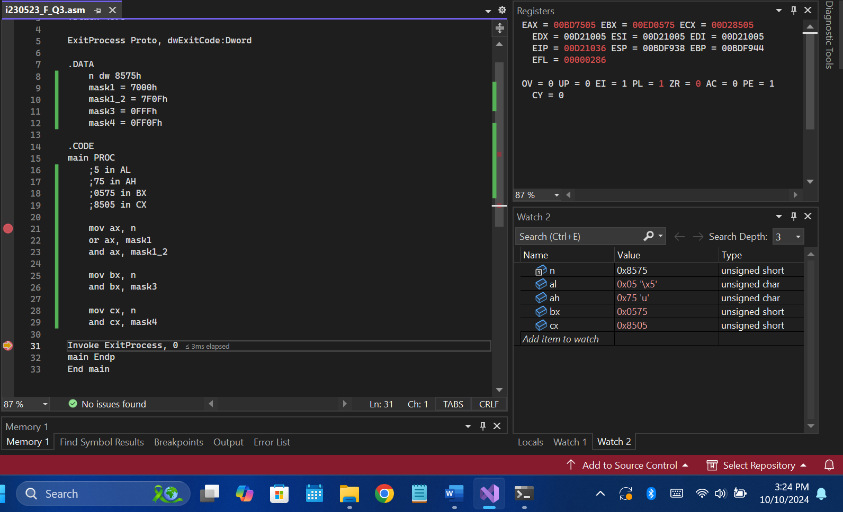
Task4: Change small letter to capital letter
Objective: consider your name is saved in an array in the small letter and you need to change all the small letters into capital letter and save it in new array.
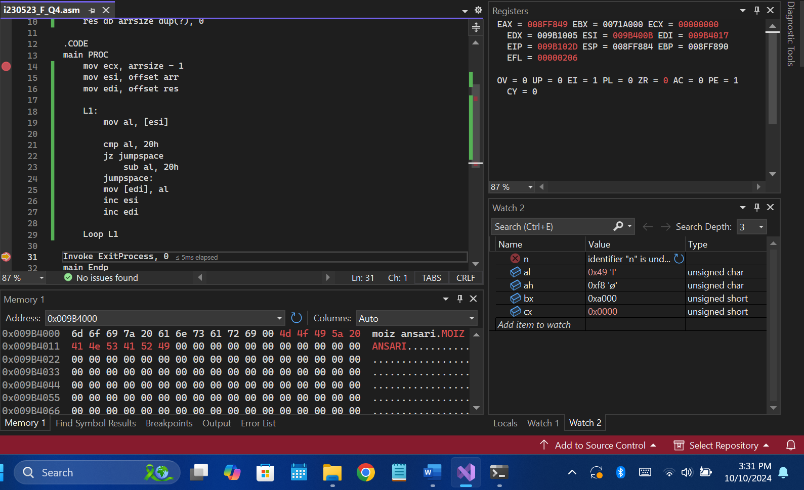
Task5: Reverse the bit of registers
Write a code that reverses all the bits in EAX, EBX, ECX, EDX and store the reversed values in the array name rev_reg_value.
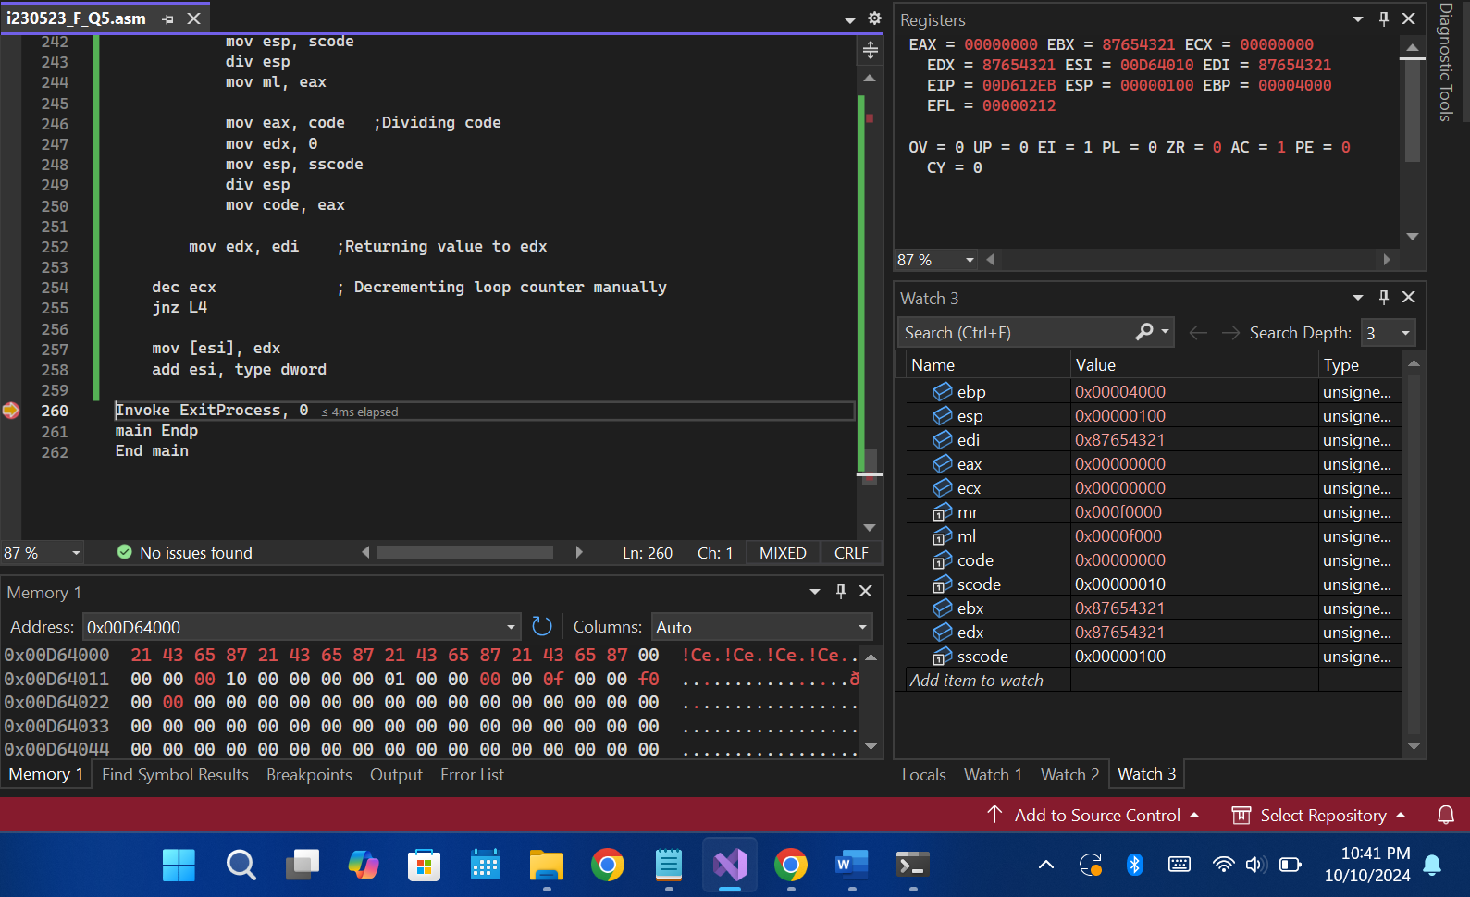
Task 6: Modify the higher bits in 16-bit registers
- Write a single instruction using 16-bit operands that clears the high 8 bits of AX and does not change the low 8 bits.
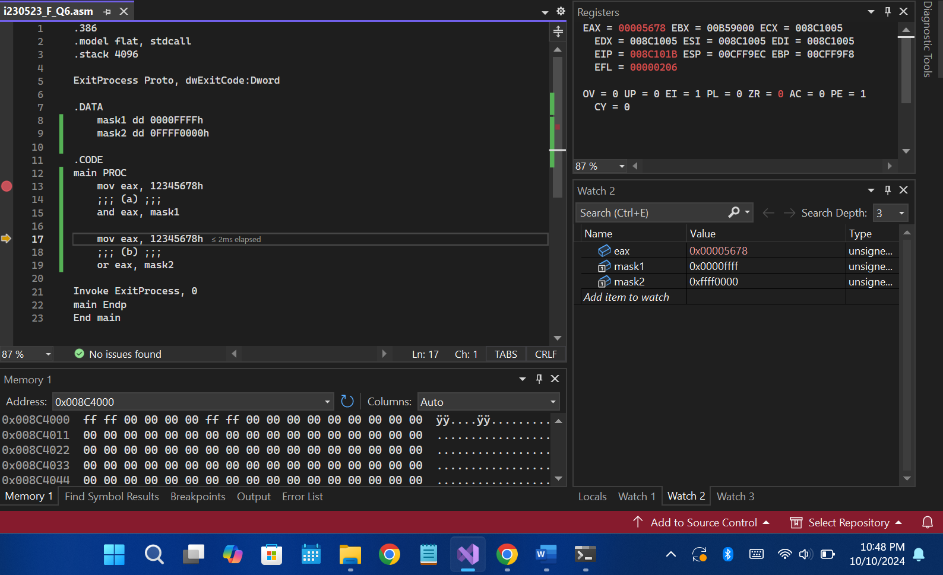
- Write a single instruction using 16-bit operands that sets the high 8 bits of AX and does not change the low 8 bits.
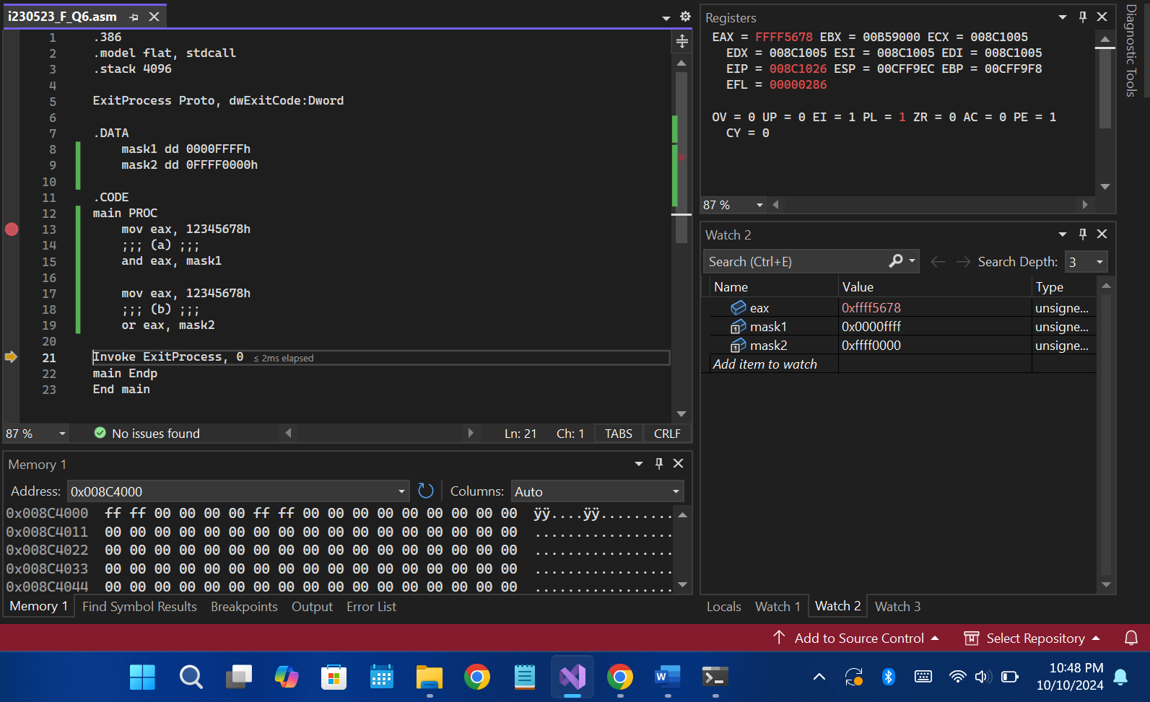

Task 7: Finding the Smallest Element in an Array
Objective: Consider an array of 10 elements. Loop through the array and determine the smallest element. Store the result in AX.
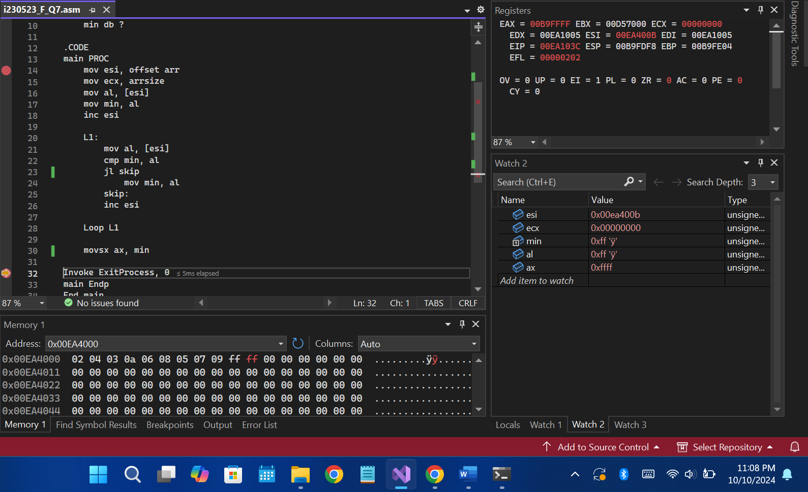
Task 8: Finding the Highest Element in an Array
Objective: Consider an array of 10 elements. Loop through the array and identify the highest element. Store the result in AX.
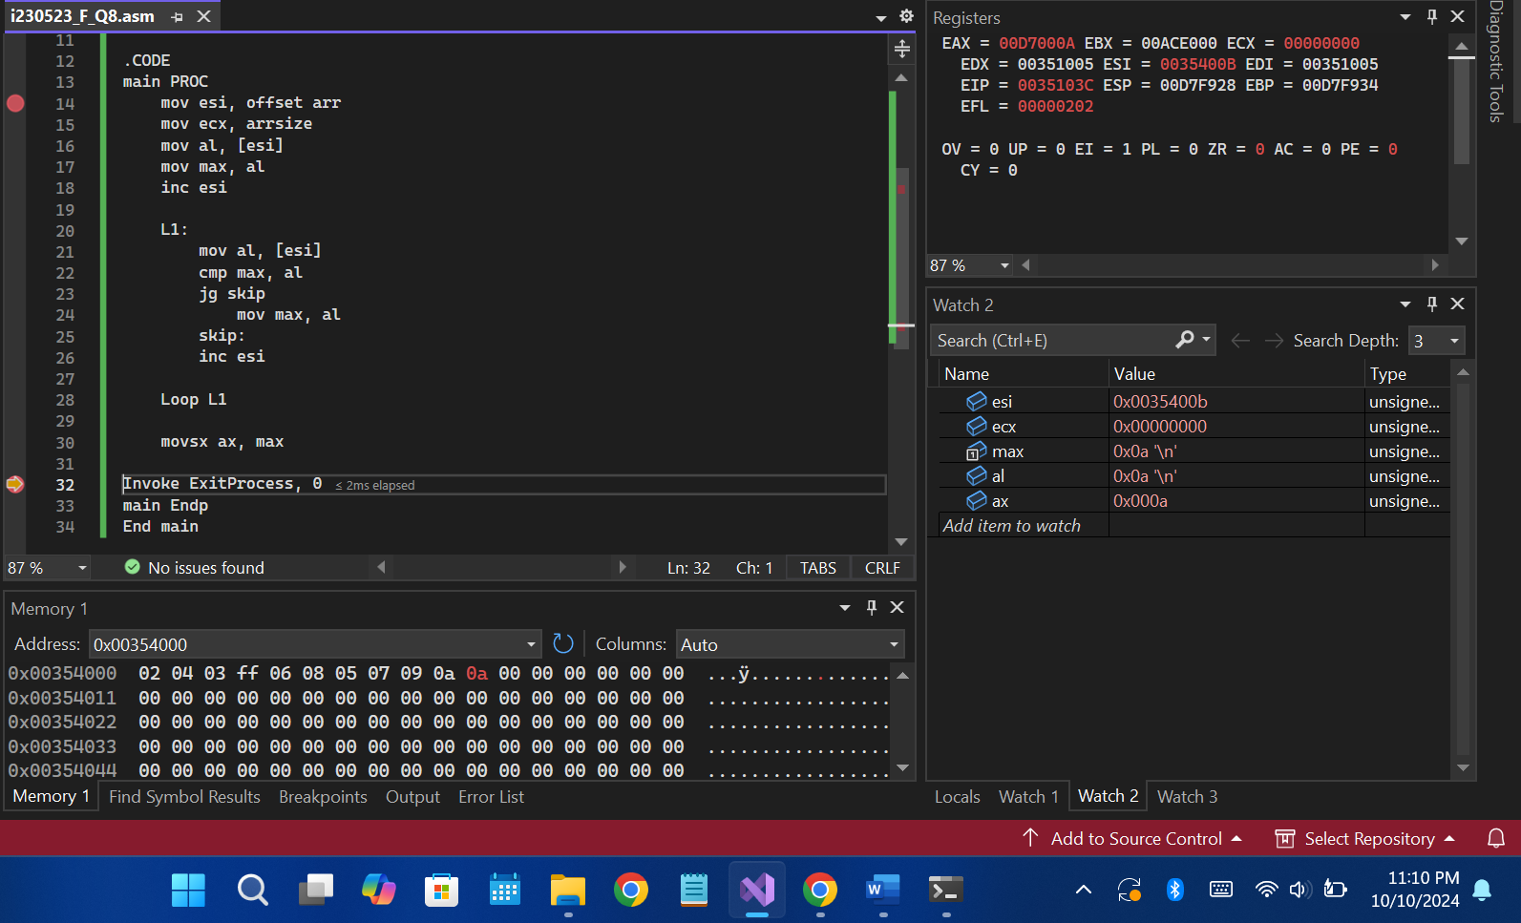

Submission Format:
Comment all the code files well enough and add explanation on how the flags are set.
Final Submission:
You will submit a zip, inside it will be all of your tasks.
The final zip submission format is: i23-1234_LAB7.zip
(Note: Submissions not following the format will not be graded.

